**SQL Queries**

1) Write a query for the HR department to produce the addresses of all the departments.

Use the LOCATIONS and COUNTRIES tables. Show the location ID, street address,

city, state or province, and country in the output. Run the query



Ans. select locations.location_id, locations.street_address, locations.city, locations.state_province,

countries.country_name

from locations inner join countries on locations.country_id=countries.country_id;

2) The HR department needs a report of employees in Toronto. Display the last name, job,

department number, and department name for all employees who work in Toronto.



Ans. Select employees.last_name, employees.job_id, employees.department_id, departments.department_name

from employees

join departments on employees.department_id=departments.department_id

join locations on departments.location_id=locations.location_id

where city='Toronto';

3) Create a report for HR that displays the last name and salary of every employee who reports to

King.



Ans. select employees.last_name,employees.salary

from employees

where manager_id=(select employee_id from employees where last_name='king');

4) Create Table MY_EMPLOYEE. Description is shown below:

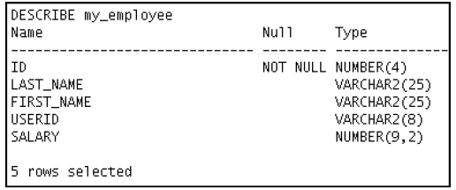

Ans. create table my_employee(id int(4) not null, last_name varchar(25), first_name varchar(25), user_id varchar(8), salary decimal(9,2));

5) Add the following data to the MY_EMPLOYEE table

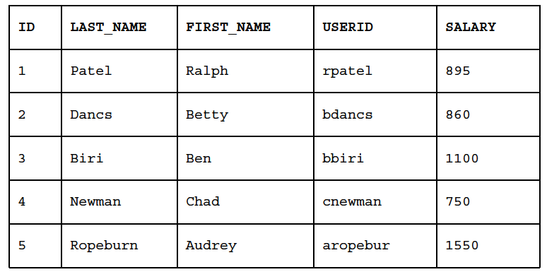

Ans.insert into my_employee(id, last_name, first_name, user_id, salary)

values(1, 'Patel', 'Ralph', 'rpatel', 895), (2, 'Dancs', 'Betty', 'bdancs', 860), (3,'Biri','Ben','bbiri',1100), (4, 'Newman', 'Chad', 'cnewman', 750) , (5,'Ropeburn','Audrey','aropebur',1550));

6) Change the last name of employee 3 to Drexler.

Ans. update my_employee

set last_name='Drexler'

where id=3;

7) Change the salary to $1,000 for all employees who have a salary less than $900.

Ans. update my_employee

set salary=1000

where salary<900;

8) Delete Betty Dancs from the MY_EMPLOYEE table.

Ans. delete from my_employee

where last_name='dancs';

9) Mark an intermediate point in the processing of the transaction.

Ans. savepoint id;

10) Delete all the rows from the MY_EMPLOYEE table. Confirm that the table is empty.

Ans. delete from my_employee;

11) Discard the most recent DELETE operation.

Ans. rollback to savepoint id;

12) Make the data addition permanent.

Ans. commit;

13) The staff in the HR department wants to hide some of the data in the EMPLOYEES table. Create

a view called EMPLOYEES_VU based on the employee numbers, employee last names, and

department numbers from the EMPLOYEES table. The heading for the employee name should be

EMPLOYEE.

Ans.create view employees_vu as

select id, last_name

from my_employee;

Confirm that the view works. Display the contents of the EMPLOYEES_VU view

Ans. select * from employees_vu;